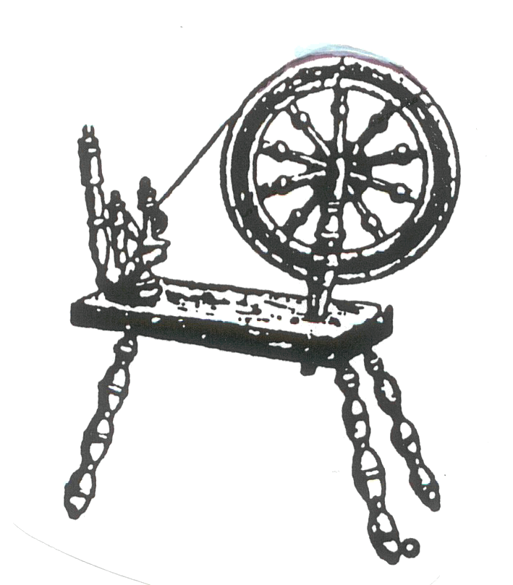
Most Ancient Union Grand Court
Heroines of Jericho PHA ~ Florida & Jurisdiction
Working under the protection of the Most Worshipful Union Grand Lodge ~ Free and Accepted
Masons PHA Florida & Belize, Central America & Jurisdiction, Inc.

Date

Dear Heroine_______________________________________,

This letter stands as a reminder to you regarding your ____________Annual Return.

Annual assessment is due to Grand Court Secretary, Heroine Sharon Lucas no later than November 30th of each year, which is the final due date.

Your Most Ancient Matron is not obligated to withhold her Court’s Annual Return Report after the due date because she is waiting on a member to pay her assessment.

The decision to withhold the report after the due date renders the court a fine of $25.00 and (You, the member) must also pay a fine of $25.00.

Please make your money order payable to: Most Ancient Union Grand Court. This
fee is to be given to your District Deputy immediately. It Is Not to be sent to the Grand Court Secretary. Your District Deputy is responsible for sending your fee to the Grand Court Secretary, Heroine Sharon Lucas.

We gladly appreciate your commitment to The Heroines of Jericho’s Constitution and Bylaws and to your Court (Article IX Section 10 and Article V Section 7).

Yours In The Bond Of the Scarlet Cord,

Vernell B. Douglas Marcus Brinson
Heroine Vernell B. Douglas Hero Marcus Brinson
Most Ancient Grand Matron Most Worthy Grand Joshua

Attest:
Heroine Sharon E. Lucas
Grand Court Secretary

